**5.1 Scenario**

The library user is required to register an account in the library system by providing their information. Next, the system will match the user details with the existing user ID in the account file to check whether the new user ID is same with the existing user ID. For valid registration, library user is required to key in their user ID and password to login. The system will access the account file to match the existing user ID and password with the current user ID and password. For invalid login, the system will exit. For valid login, the system is entering to the process of borrowing book.

Firstly, the library user must provide the searching details such as book’s name to the system and the system will provide the available books to the user. To borrow book, library user must provide book reservation details to the system. Next, the system will store the book reservation details in the book reservation file. After that, the library user must provide the book collection confirmation to the system. Then, the system will update the book status and store the data into the book file. To renew the book’s borrowing duration, the user must provide book renewal details to the system and the data will be stored into book file.

To return book, library user must send the book return confirmation to the system. The system will update the book status after the library user has returned the book and store the data into the book file. For those who did not return book at the given date, penalty will be given. The system will calculate fines based on the book return details. After that, the system will record the fines details into the loan file. Then, the system will send the fines amount to the library user who did not return book on time and library user must provide the banking details to the system in order to pay the fines. To receive the fines payment from library user, the system must provide the library user banking details to bank. When the library user banking details is confirmed by bank, then the user’s payment will be received by the system. Finally, the system will send the fines receipt to the library user.

Lastly, the system will generate a report when the library manager request for a report. After generating a report, the system will send the generated report to the library manager. The report will be generated by using the details from the loan, book reservation and payment file.

**5.2 Context Diagram**

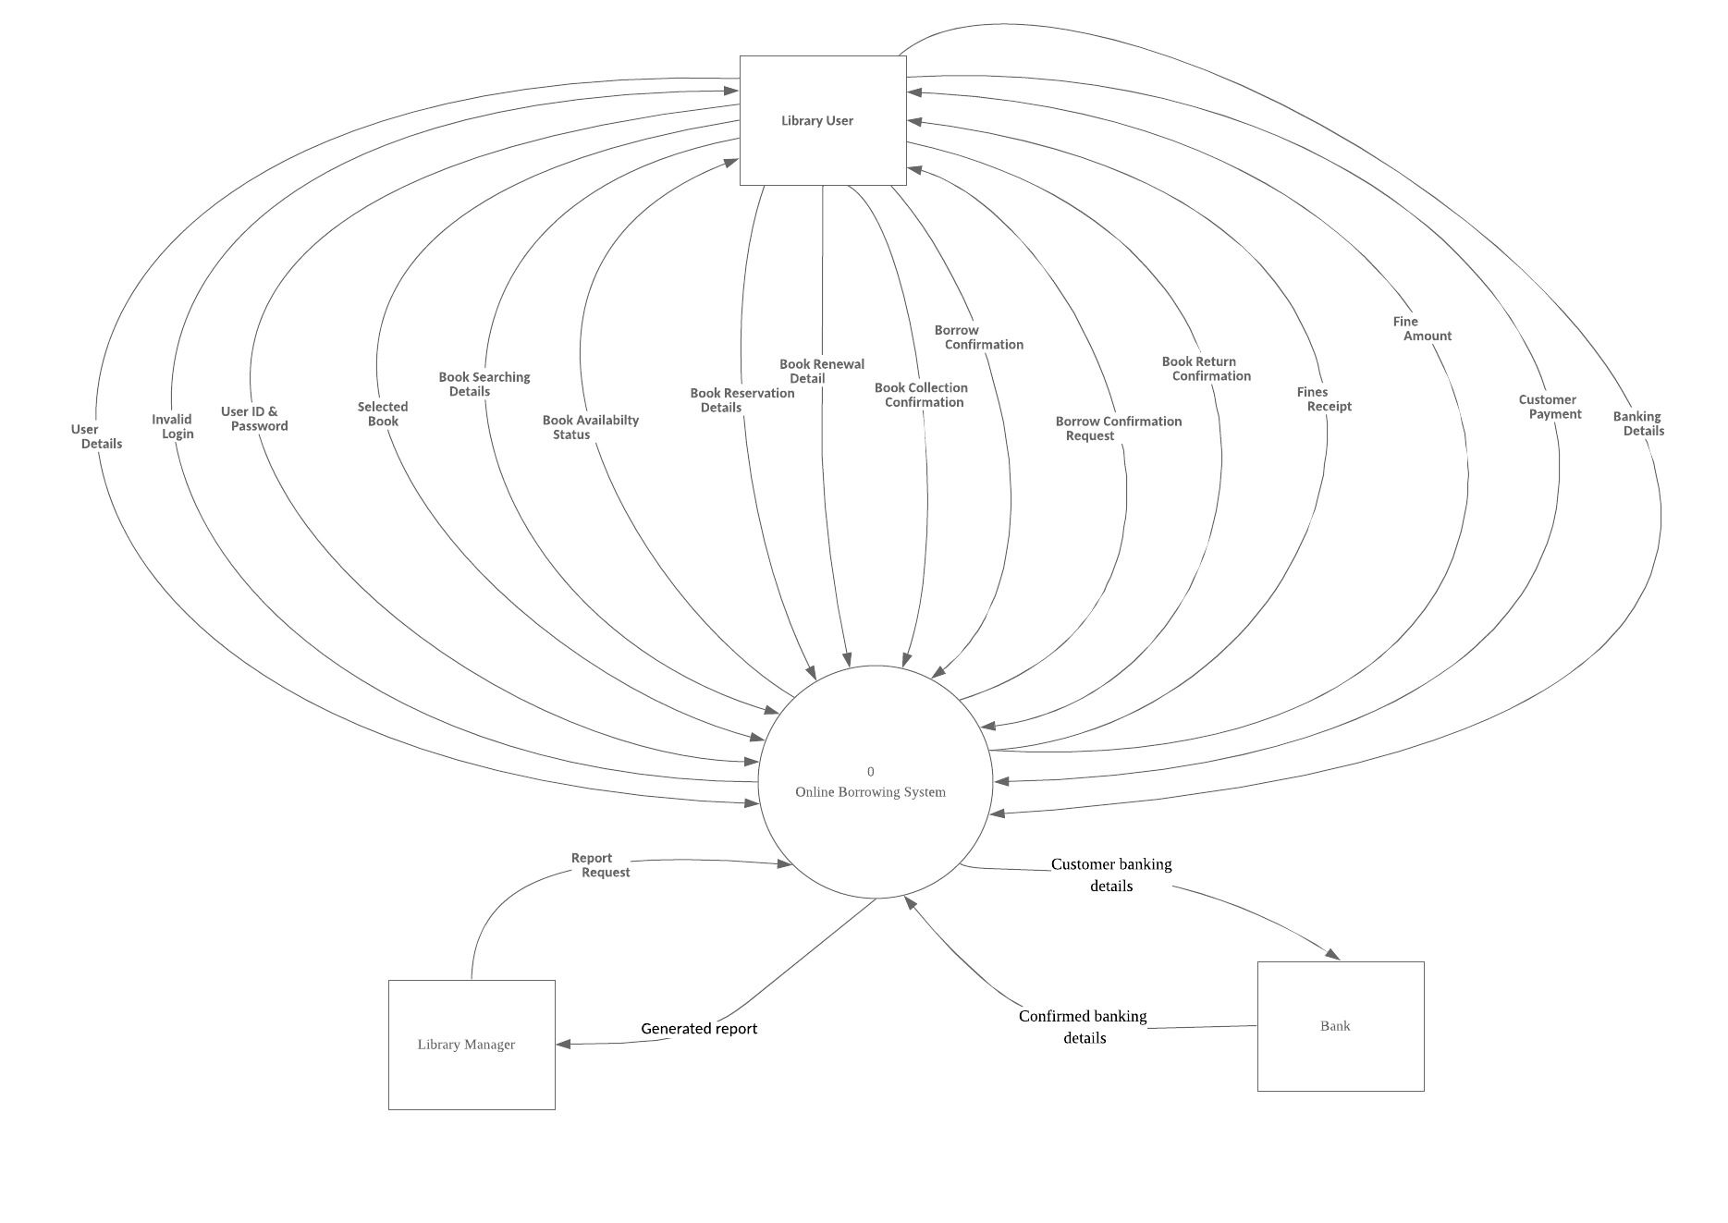

**5.3 DFD Diagrams**

**5.3.1 DFD 0 Diagram**



**5.3.2 DFD 1 Diagram**

